Each one of these designs and words are Copyrighted to my Websites
and are Round like this one with more words as illustrated.
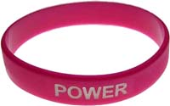
These are to gauge your interest – please fill in the Form to let me know.
This would be much appreciated.
The manufacture of Silicon Bracelets will depend on the response I receive!

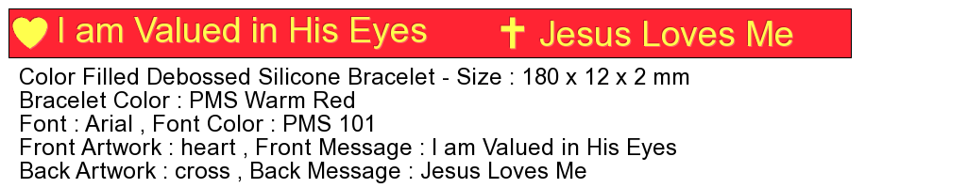

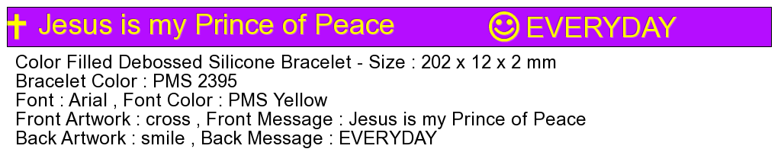

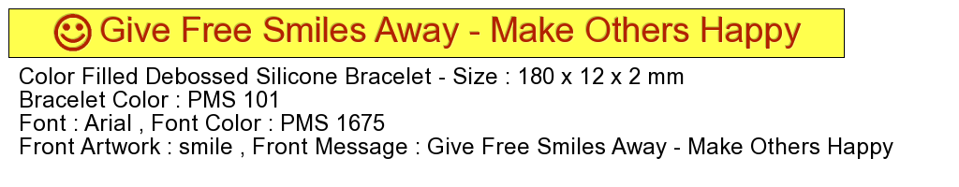

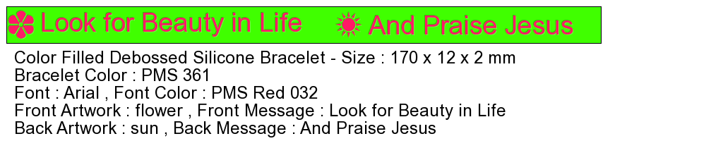
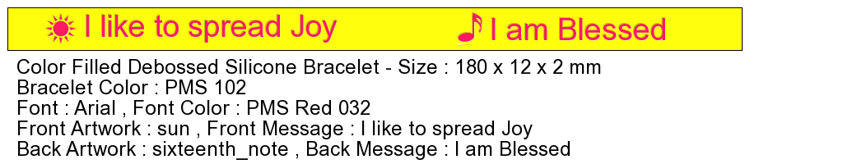

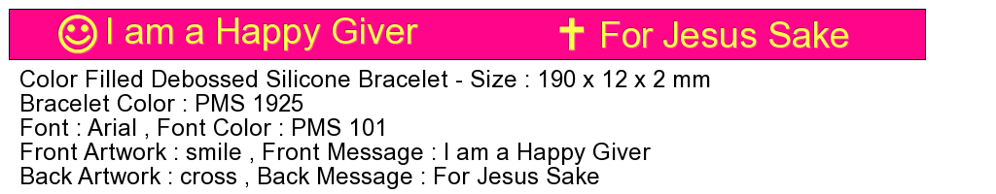

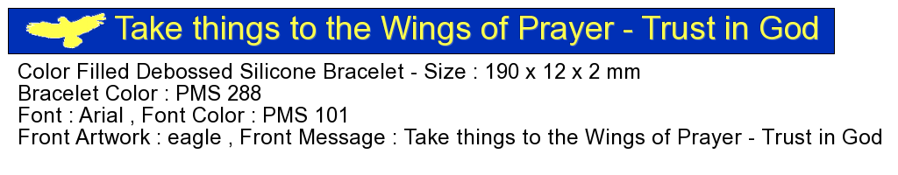

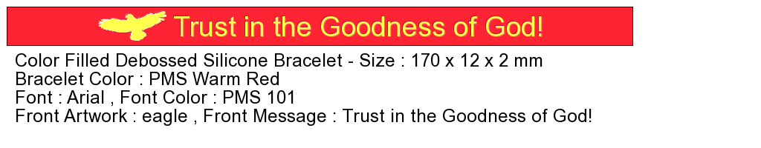
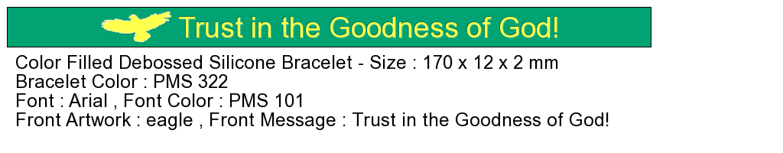
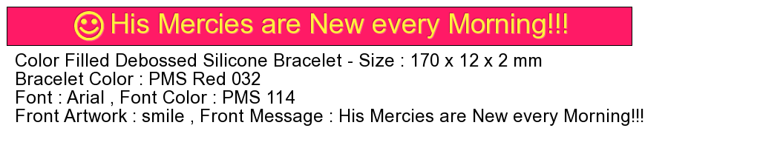
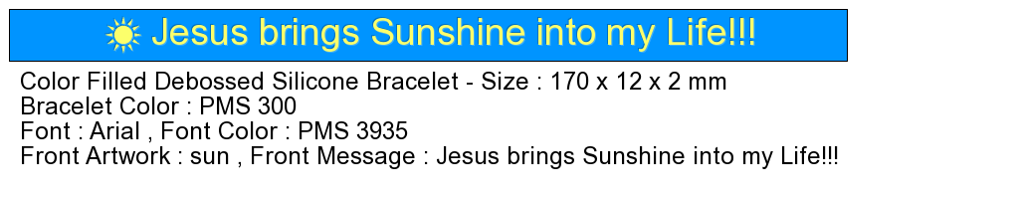
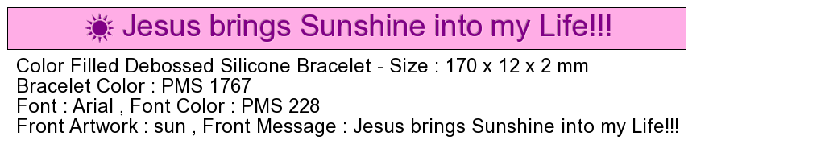
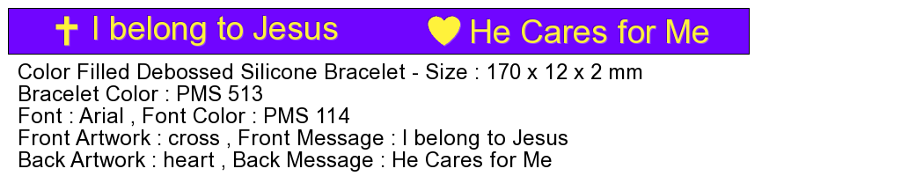

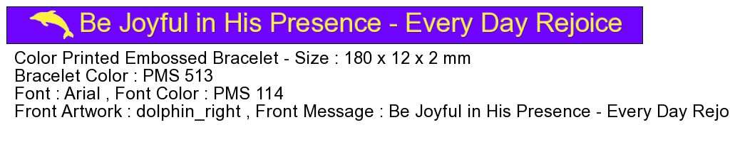

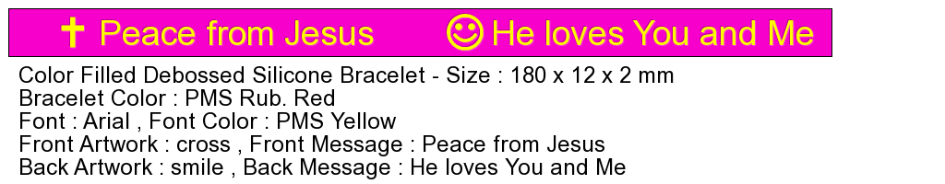

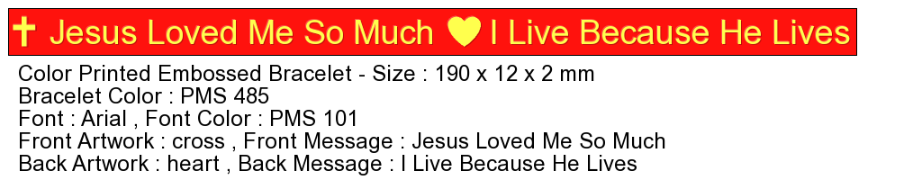

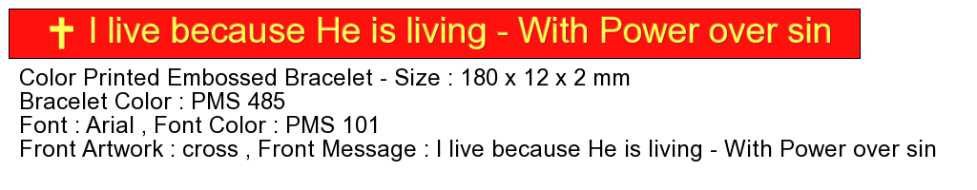

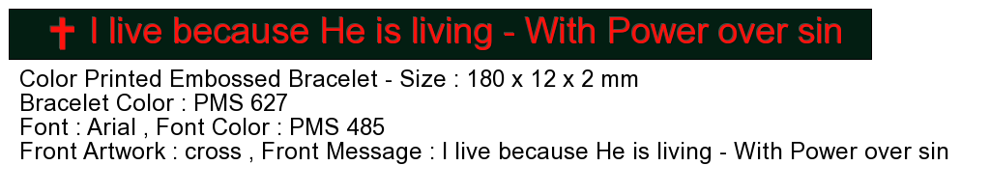

THESE BRACELETS ARE TO WEAR FOR REMINDERS AND INSPIRATION.
THEY ARE ALSO GREAT FOR SPREADING THE GOOD NEWS OF JESUS
BECAUSE SOMETIMES SOMEONE WILL ASK ABOUT THEM.
THEY ALSO MAKE A NICE INEXPENSIVE GIFT THAT LASTS A LONG TIME.
DID YOU KNOW THAT THE JEWS OFTEN USED TO WEAR
AN ARM BAND WITH SCRIPTURES ON THEM?
THEY FELT THE BLESSING OF GOD IN DOING THIS!

